Case Study Report



**Tech Saksham**

Data Analytics with Power BI

**“Analysis of Commercial Electricity Consumption in Indian State.”**

**“A.P.C. Mahalaxmi College for womens”**

|  |  |
| --- | --- |
| **NM ID** | **NAME** |
| 394A47D18D04FE6B1D341BFBA3F9A496 | N.Pavithra |

|  |  |
| --- | --- |
|  |  |
|  | Trainer Name : R.Umamaheswari |
|  | Master Trainer : R.Umamaheswari |

**ABSTRACT**

The demand for energy has been increasing over the years in India,whichmaybethe result of its rapid economic growth trajectory. In this context, thisstudyexaminesthe direction of the Granger-causal relationship between electricity consumption and economic growth at the state and sectoral levels in India. In doing so, the panel cointegration tests with the structural break, the heterogeneous panel causality test, andthepanelVARbasedimpulse-responsemodelareemployed.

Further,theresultsprovideevidenceforthepresenceofunidirectional Granger-causalityﬂowinginthedirectionofoveralleconomicgrowthtoelectricity consumptionattheaggregatestatelevel.

**INDEX**

|  |  |  |
| --- | --- | --- |
| **Sr. No.** | **Table of Contents** | **Page No.** |
| 1 | Chapter 1: Introduction | 4 |
| 2 | Chapter 2: Services and Tools Required | 6 |
| 3 | Chapter 3: Project Architecture | 7 |
| 4 | Chapter 4: Modeling and Result | 9 |
| 5 | Conclusion | 12 |
| 6 | Future Scope | 13 |
| 7 | References | 13 |
| 8 | Links | 14 |

**CHAPTER 1**

**INTRODUCTION**

* 1. **Problem Statement**

Electricity outages have been a major impediment to doing business in countries worldwide Eﬃcient electricity supply is an important prerequisite for aidingsustained agricultural and industrial growth to any economy. Electricity contributes to agricultural production either directly, by energising agricultural machinery and irrigation systems, or indirectly, as a complement to other inputs such as fertilizers and pesticides. Electricity in rural areas is widely believed to be a stimulus factor for increasedagriculturalproductivityandmechanization

* 1. **Proposed Solution**

The proposed solution involves leveraging data analytics techniques with data sourced from the cloud and web to conduct an in-depth analysis of commercial electricity consumption in an Indian state.As we know, developing country like India has been promoting itself by enhancing various initiatives on all sectors and regions to achieve economic targets and for prepare to meet global competition for proclaim eﬃcient nation. Accumulation of changes in energy consumption especially commercial energy pointed is indirectly spurs the problems on the consumption of non-commercial energy regularly consumes by ruralpeople.Though,initiationof various commercial energy is alwayssupportstoeconomicgrowthandit neverever make worsen to that yet looking for another trend ofconsumptioninnon-commercial type and its reﬂects among the rural have to consider and necessary steps need to execute for the support of primary energy consumers and to boost economy level. Visualization tools will be used to present ﬁndings comprehensively, informed decision-making, while continuous monitoring will ensure ongoing optimizationofenergyresourcesandeﬃciencyinitiatives.

* 1. **Feature**

Utilisationpatterns:Analyzepeakandoff-peakconsumptiontimestoidentify trendsincommercialelectricityusage,aidinginresourceallocationand infrastructureplanning.

● SectoralBreakdown:Segmentconsumptiondatabyindustrysectorsto understandwhichsectorsarethelargestconsumers,enablingtargetedenergy eﬃciencyinitiativesandtariffstructure.

● SeasonalVariation :Evaluateseasonalﬂuctuationsinelectricitydemandto anticipatefuturedemands,optimizesupplychainmanagement,andimplement demand-sidemanagementstrategies.

* 1. **Advantages**

● EnchanceResourceManagement: Electricitymanagementisavasttopicin environmentalsciencethatdealswiththecontrol,monitoring,andconservation ofenergyconsumption.Thisnotonlyincludeseﬃciencyinconsumptionbut alsothecreationanddistributionofelectricpower.

● ProactiveDecision-Making:Byleveragingcloud/web-baseddataanalytics, stakeholderscanproactivelyidentifyconsumptionpatterns,anticipatedemand ﬂuctuations,andplaninfrastructureupgradesormaintenanceactivities accordingly.Thisproactiveapproachenhancesgridstability,reduces downtime,andenhancesoveralloperationaleﬃciency.

* 1. **Scope**

BasedonrecentdatafromtheCentralElectricityAuthority(CEA), thepeakpowerdemandisexpectedtoreach230GWby2035.Meetingthisdemandrequiresstrategiccapacityadditionandrobustinfrastructuredevelopment.PoweringIndia:ananalysisofcommercialelectricityconsumptioninanIndianstateusingdataanalyticssourcedfromcloudorweb platformswouldentailexaminingtrends,patterns,andfactors influencingelectricityusage.Thisanalysiscouldencompassidentifyingpeakconsuonperiods,understandingtheimpactofeconomicactivitiesandindustrialsectorsonelectricitydemand, detectinganomaliesorinefficienciesinconsumptionpatterns,and forecastingfutureconsumptiontrendstoaidinresourceallocationandinfrastructnning.Additionally,itcouldinvolveexploringcorrelationsbetweenelectricnalfactorssuchas weatherconditions,demographicshifts,orpolicychanges,providingorpolicymakers,utilityproviders,andbusinessestooptimizeenergymanagementstrategiesandpromotesustainable development.

**CHAPTER 2**

**SERVICES AND TOOLS REQUIRED**

**2.1 Services Used**

● Datacollectionandintegration Dependingonyourdatasourcesandneeds,youcanusedifferentmethodsto collectenergydata,suchasmanualreading,wiredorwirelesscommunication, orcloud-basedservices.Manualreadingisthesimplestbutmost time-consuminganderror-pronemethod..Thiscouldincludeindustries,oﬃces, retailoutlets,etc.Dataintegrationtechniqueswillbecrucialtoensure uniformityandconsistencyinthedataset.

● DescriptiveAnalytics: Performdescriptiveanalyticstounderstandthecurrent patternsandtrendsincommercialelectricityconsumption.Thisinvolves summarizingthedatathroughmeasuressuchasmean,median,mode,and standarddeviation,aswellasvisualizingthedatausingchartsandgraphsto identifyanyoutliersoranomalies.

● PredictiveModeling:Preciseelectricityforecastingisapertinent challengeineffectivelycontrollingthesupplyanddemandofpower. Thisisduetotheinherentvolatilityofelectricity,whichcannotbe storedandmustbeutilisedpromptly.

**2.2 Tools and Software used**

**Tools**:

**PowerBI**: The main tool for this project is PowerBI, which will be used to create interactive dashboards for real-time data visualization.

**Power Query**: This is a data connection technology that enables you to discover, connect, combine, and refine data across a wide variety of sources.

**Software Requirements**:

**PowerBI Desktop**: This is a Windows application that you can use to create reports and publish them to PowerBI.

**PowerBI Service**: This is an online SaaS (Software as a Service) service that you use to publish reports, create new dashboards, and share insights.

**CHAPTER 3**

**PROJECT ARCHITECTURE**

**3.1 Architecture**

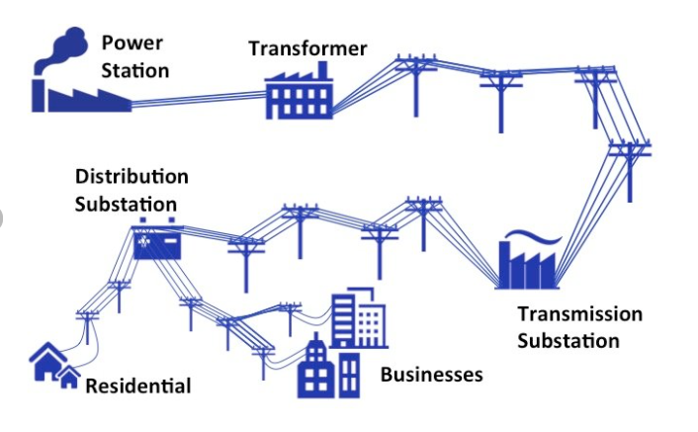

**\*\*DataAnalyticsArchitectureforCommercialElectricityConsumptioninIndian State:\*\***

● Datacollection: Gather data from cloud/websources including government databases,utility companies,and Io Tdevices.

● DataPreprocessing : Cleanse and preprocess the data to handle missing values,outliers,and inconsistencies.

● DataStorage :Store the processed data inascalable and eﬃcient data storage system such as a dataware house or data lake.

● Dataintegration: Integratedata from multiple sources to create a comprehensive dataset for analysis.

● AnalysisandModeling:Utilize machine learning and statistical techniques to analyze the data and build predictive models.

● Visualization:Create visualizations such as charts,graphs,and maps to present insights and trends in electricity consumption.

● Interpretation: Interpret there sults of the analysis to understand patterns, identify consumption drivers,and inform decision-making.

● ReportingandDeployment: Generate reports and deploythe analytics solution forstake holders to use in optimizing electricity consumption strategies.

**CHAPTER 4**

**MODELING AND RESULT**

**Manage relationship**

The “disp” file will be used as the main connector as it contains most key identifier (account id, client id and disp id) which can be use to relates the 8 data files together. The “district” file is use to link the client profile geographically with “district id”

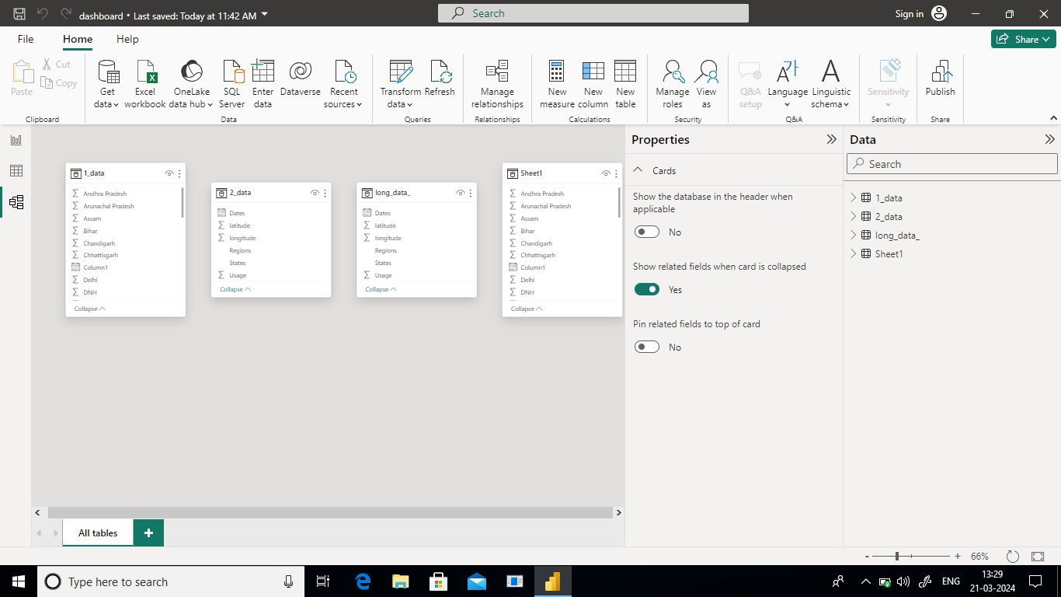

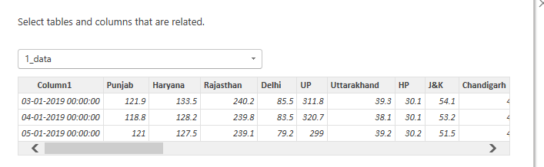

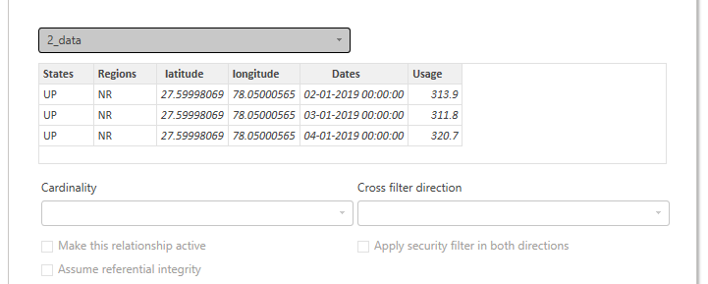

**Dashboard**

Analysis of Commercial Electricity Consumption in Indian State.

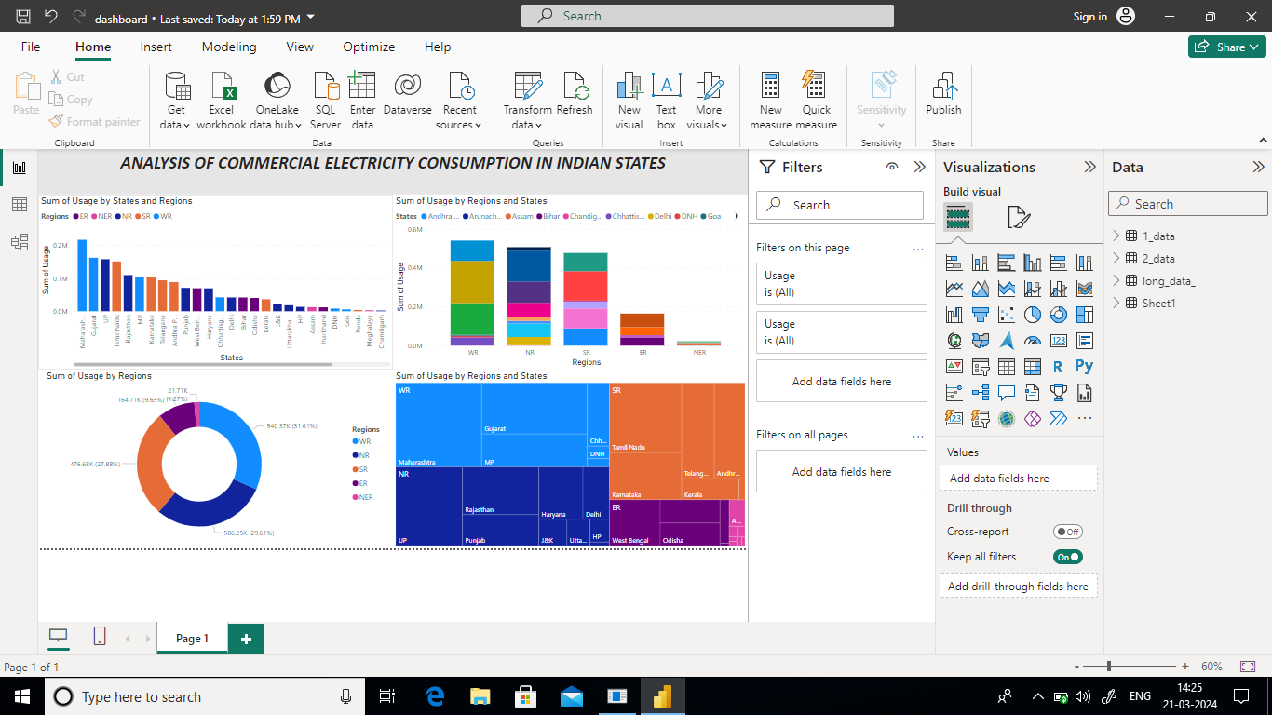

**CONCLUSION**

After conducting a comprehensive analysis of commercial electricity consumption in the selected Indian state using data analytics with datasourced from cloud/webplatforms ,It is evident that several key patterns and trends emerge. The nanalysis reveals distinct seasonal variations inconsumption ,with notable peaks during periods of economic activity and industrial production. Additionally,certain geographic regions within the state exhibit higher consumptionrates, likely influenced by factors such as urbanization,industrial development ,and infrastructure availability. Furthermore, the study highlights the importance of proactive energy managemen tstrategies,including demand-side management initiatives and investment inrenewable energy infrastructure,toensure sustainable electricity usage and mitigate potential supply constraints.Overall,these insight sunder score the significance of leveraging data-driven approaches to optimize commercial electricity consumption and drive towards a more resilient and efficient energy ecosystem in the state.

**FUTURE SCOPE**

Looking ahead, there are several promising avenues for further exploration and enhancement of the analysis of commercial electricity consumption in the Indian state leveraging data analytics and cloud/web-based data sources. Future research could delve deeper into granular sub-sector analysis to identify specific industries or business categories driving electricity demand and develop targetedenergyefficiencymeasurestailoredtotheiruniquerequirements. Additionally, integrating real-time data streams and advanced predictive analytics techniques can enable proactive demand forecasting and optimization, empowering stakeholders to anticipate and respond to fluctuations in electricity usage more effectively. Furthermore, exploring the intersection of emerging technologies such as Internet of Things (IoT) devices and smart meters with data analytics holds immense potential for enabling finer-grained monitoring and control of electricity consumption at the commercial level,pavingthewayfor moreagileandsustainableenergymanagementpracticesinthestate

**REFERENCES**

<https://ideas.repec.org/a/ebl/ecbull/eb-17-00173.html>

**LINK**

<https://github.com/githubtraining/hellogitworld.git>